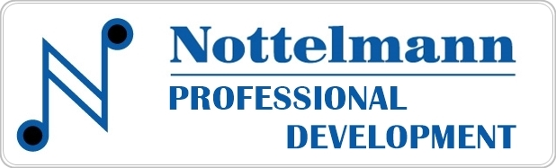
Webinar Follow-up Action Plan
Nottelmann Professional Development is a service of Nottelmann Music Company, a full-service music store based in St. Louis serving music educators, schools, students, and musicians since 1953. Our webinars are designed to instruct and award the participant one hour of professional development credit, and are offered absolutely free of charge. Successful completion of the follow-up quiz earns in a certificate of completion of the webinar. This follow-up action plan form is to help facilitate new teaching ideas and concepts with the educator.

Download and rename this form. Complete the form to create your custom application document of the webinar you viewed. This custom document may be saved for your future planning, as well for submission to an administrator.

WEBINAR – Teaching Online with Better Audio, with Evan Brown

NAME | JOB TITLE | SCHOOL/DISTRICT | DATE VIEWED
First and Last Name | Job Title | School/District | Date Viewed

Save this LINK to refer to this WEBINAR VIDEO in the future.

DIRECTIONS – Determine actions for implementation. Fill in the ACTION BOXES below with implementation and outcomes details. The boxes had unlimited user space. Tap to enter initial and completion dates. Remove extra boxes or copy and paste additional boxes for more entries.

ACTION ITEM #1 – Date to Implement - Click or tap to enter a date. Date to Complete - Click or tap to enter a date.
Title -
(create a title for future reference to this action)

ACTION ITEM #2 – Date to Implement - Click or tap to enter a date. Date to Complete - Click or tap to enter a date.
Title -

ACTION ITEM #3 – Date to Implement - Click or tap to enter a date. Date to Complete - Click or tap to enter a date.
Title -

ACTION ITEM #4 – Date to Implement - Click or tap to enter a date. Date to Complete - Click or tap to enter a date.
Title -

(Copy/paste for additional boxes as needed, delete boxes not needed.)

