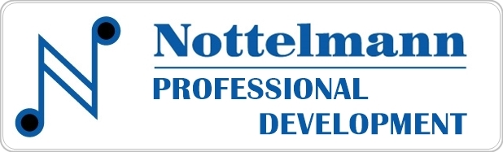
Webinar Important Notes
Nottelmann Professional Development is a service of Nottelmann Music Company, a full-service music store based in St. Louis serving music educators, schools, students, and musicians since 1953. Our webinars are designed to instruct and award the participant one hour of professional development Credit and are offered absolutely free of charge. Successful completion of the follow-up quiz earns a certificate of completion of the webinar. This form is to help document and retain important ideas and concepts from the webinar.

Download and rename this form. Complete the form to create your custom application document of the webinar you viewed. This custom document may be saved for your future planning, as well for submission to an administrator.
Webinar Title –
Ten Steps to Building a Quality Solo and Ensemble Program
in Your School
with Kim Pirtle and Kyle Donnelly

NAME | JOB TITLE | SCHOOL/DISTRICT | DATE VIEWED
First and Last Name | Job Title | School/District | Date Viewed

1 – DEVELOP INTEREST AND EXCITEMENT –

2 – ASSIGN YOUR STUDENTS –

3 – GET COMMITMENT –

4 – SELECT APPROPRIATE MUSIC -

5 – ESTABLISH THE REHEARSAL PROCESS

6 – PLAN FOR QUALITY ACCOMPANIMENT

7 – HAVE A PRE-CONTEST PERFORMANCE

8 – CAREFULLY PLAN CONTEST DAY

9 – UTILIZE ADJUDICATION INFORMATION FOR STUDENT LEARNING AND GROWTH

10 – HONOR STUDENT ACHIEVEMENT

Other interesting points:
Interesting thoughts and ideas:

Application Ideas I might want to try:

